**Stage 1 - Braveheart**

**RULES:** USPSA Competition Rules, Latest Edition **COURSE DESIGNER:** Ryan Christenson

|  |  |
| --- | --- |
| **START POSITION:** Both feet on the Shooting Sports Innovation Xs, facing downrange.  **Handgun**: Unloaded and holstered, wrists below belt. **PCC**: Unloaded, stock on belt, muzzle pointed at center of rear berm. | |
| **STAGE PROCEDURE**  See written stage briefing. | **SCORING**  **SCORING:** Comstock 26 rounds.  **TARGETS:** 13 cardboard targets  **SCORED HITS:** 2 Best hits per carboard will be scored.  **START-STOP:**  Audible - Last shot  **PENALTIES:** Per USPSA Competition Rules |

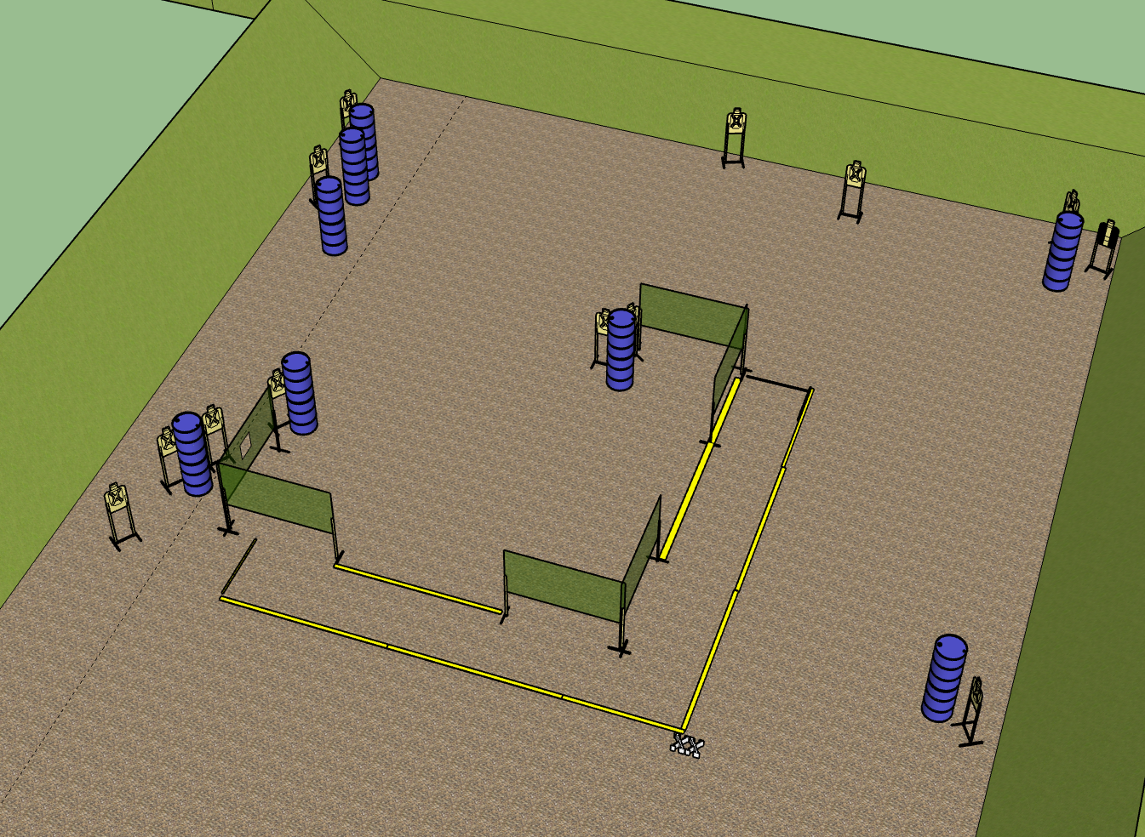

**Written Stage Briefing:**

**Stage 1- Braveheart–** is a 26-round, 130 point, Comstock Long Course. There are 13 cardboard targets. The best 2 hits per cardboard target will be scored.

**Start position** Both feet on the Shooting Sports Innovation Xs, facing downrange.

**Handgun**: Unloaded and holstered, wrists below belt.

**PCC**: Unloaded, stock on belt, muzzle pointed at center of rear berm.

On the audible start signal, engage targets from within the shooting area.

**Setup Notes:**

6 Single Wall Stands

3 Double Wall Stands

5 Full Walls

1 Ported Wall

13 Target stands / 26 Target Sticks

1 Starting Xs

16+ Barrels